
Integrating Educational Technology into Teaching

Power Point Presentation
Tutorial For
The 3 Grades of Students

By
Hilal Sener
Seda Bekfelavi



Power Point Tutorial

This tutorial is prepared for the third grade of students. Power point tutorial helps students to make the presentation with power point. With this tutorial, students will be able to understand the slides concepts. They will be able to add pictures and texts to the slides. They will able to change and implement the design of the presentation. In this tutorial, students prepare the power point presentation about 23 April National Children Festival.

Required System Settings
This tutorial assumes that you have installed the power point on your computer.

POWER POINT PRESENTATION TUTORIAL
Dear friends welcome to the power point presentation tutorial. At the end of the tutorial, you will create the presentation slides as shown below.



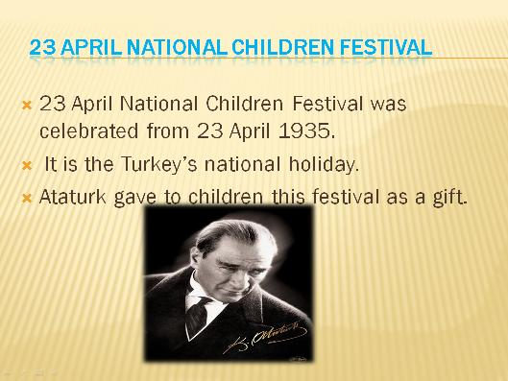



LET’S START 
This power point presentation consists of 4 slides. Presentation is related with the 23 April National Children Festival. You will add the pictures, automatic shapes and texts to the slides. You will change the design of the presentation.
1st Step: Opening Power Point Program
Firstly, you click on the start icon. When you click on the start icon, it will open programs’ icons. You will click on the icon of the Microsoft Office PowerPoint2007.

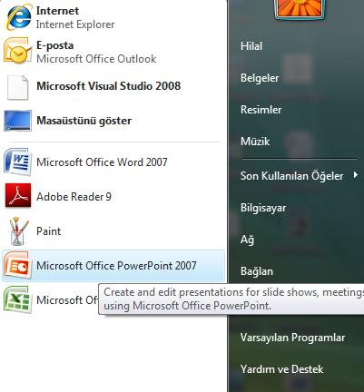

You click on this icon to open power point.
2nd Step: Creating Slide and Adding Text
When you click on the power point icon, you will see like shown below.
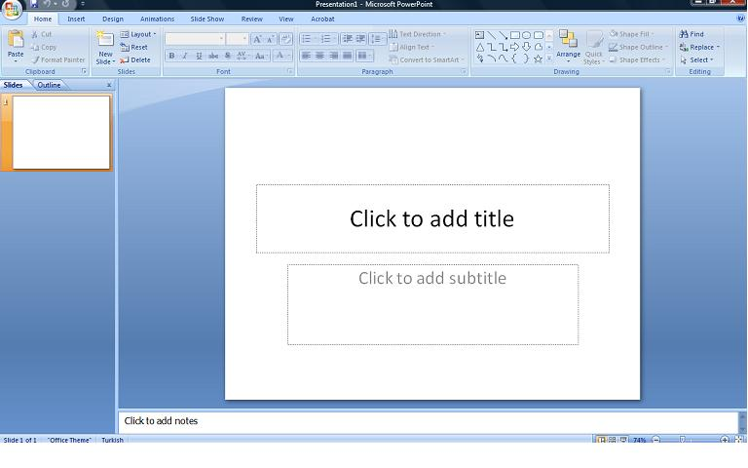

Lets start to create slides !

Lets write the title here. To write the title you should click the title textbox. A tick gray border appears around the textbox that it is selected.Write here 23 April National Children Festival.
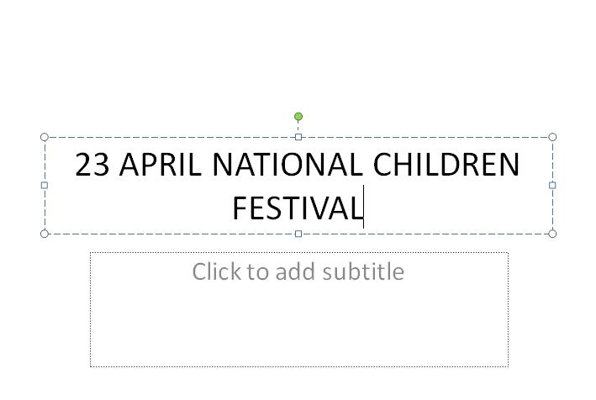
3rd Step: Changing Slide Design
Now, change the slide design of the presentation.
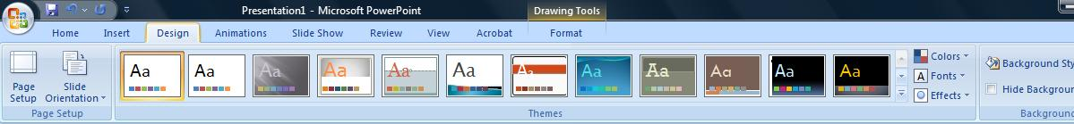

In the picture, you see the tool bar of the power point. If you click on the Design icon, you will see the different templates of the power point.

You can scrool to see different templates by clicking the cursor.

After choosing one of them, you can apply the template to the slide.


When you click on the one of them, template of the power point changes.
Congratulations! Now you can move on fourth step. ☺
4th Step: Adding Picture
Now, you will add the picture to the slide.
! Tip: When you want to add anything, you should click the insert link.
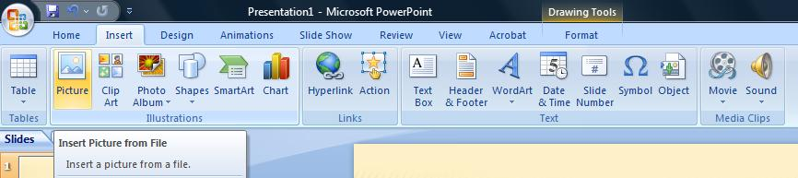

In the tool bar, there is a insert link. When you click on the insert link, you will see the picture icon. You should click on the picture icon to add the picture to your slide.

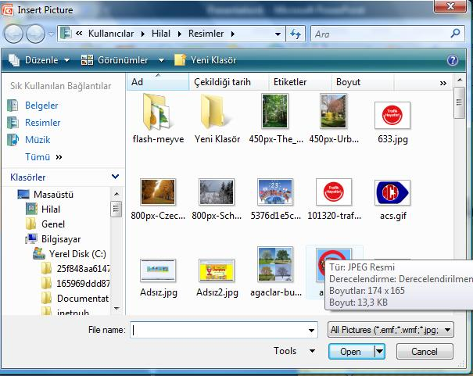
After clicking the picture icon, file diolag box opens. You can choose the one of the picture to add the your slide.

You should give importance where you add the picture. You can resize your picture in the slide.

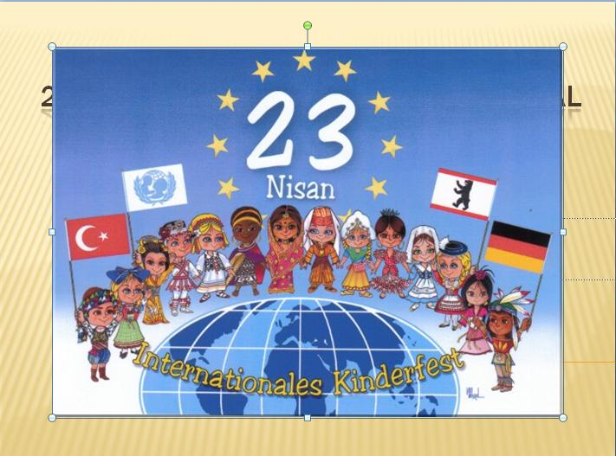
If picture size is bigger, it can cover your slide. To avoid this, you can resize yor picture from small points of the picture border. You can make picture bigger or smaller.

5th Step: Making Bold and Changing Font Color
Now, you can make bold your text and change your font color.
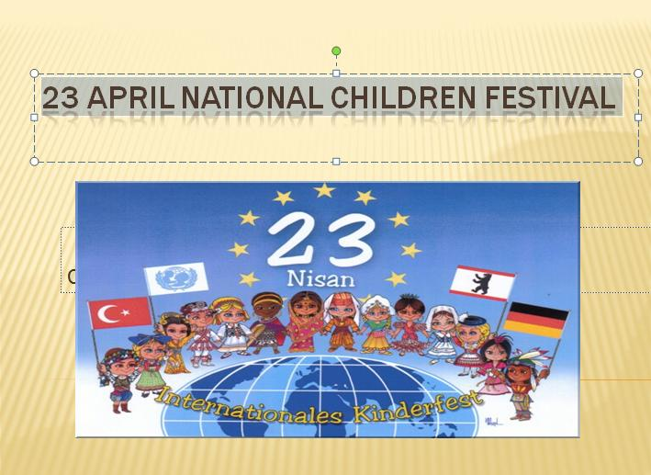

To make the differences in your text, you should select the text with the mouse. Then you can change the font color.

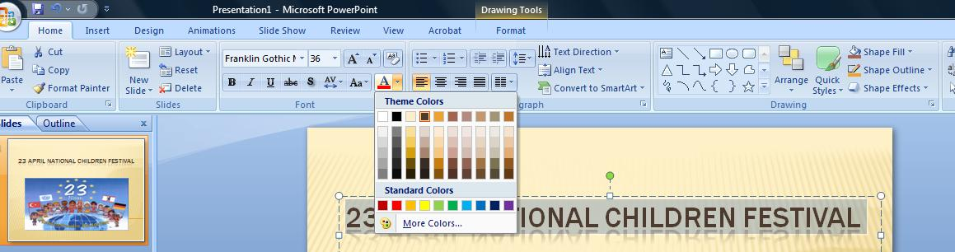
Click the Bold icon to make the text bold.
Click the font color icon to change the text color. Make the font color blue.

☺ Congratulations! You have created the first slide. ☺

6th Step: Adding New Slide
You have created the first slide. Now, add the new slide to the power point presentation.
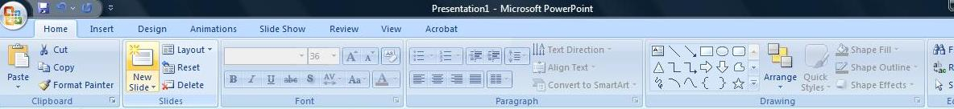

Click the New Slide icon from the tool bar.
When you click the New slide icon, new slide is added.

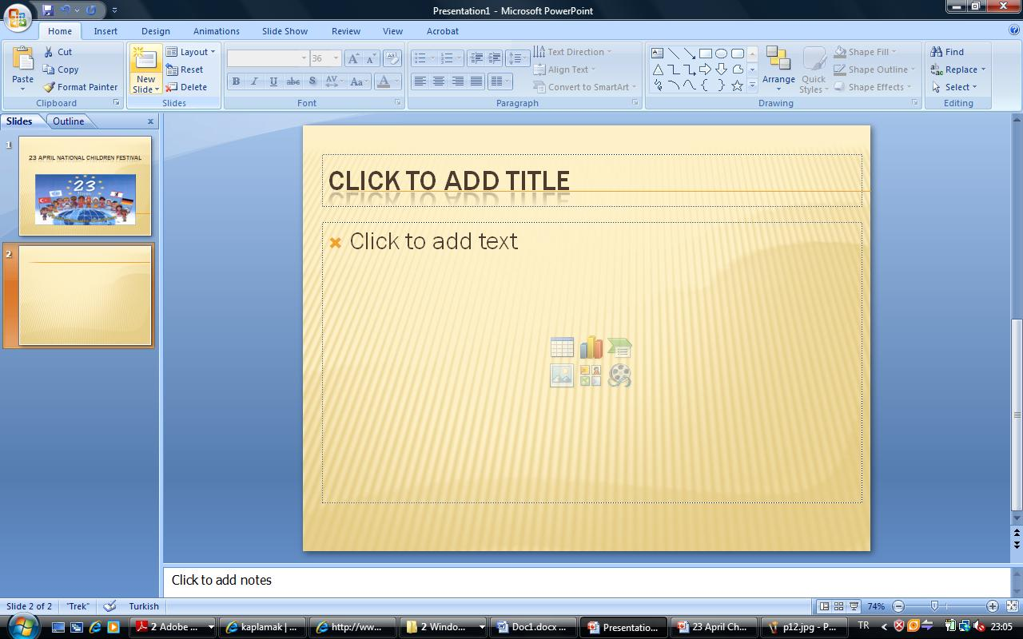

7th Step: Adding Text
Now, you make the header to the above textbox like in the 2nd step. Write the same title with the second step. Then, change the font color to blue. After that, make bolder.

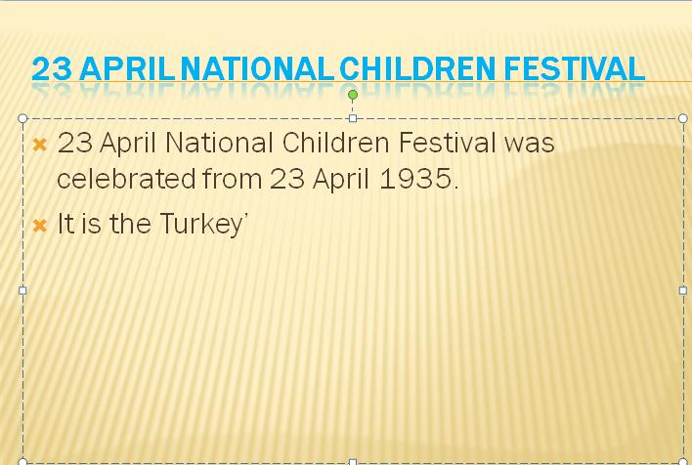
Click in the second textbox. A tick gray border appears around the textbox indicating it is selected. Now you can start to write the sentences.

8th Step: Adding Picture for the Second Slide
Now, you can add the Ataturk Picture to the slide. Again, you should resize the picture from small points of the picture border. Look at the 4th Step to add the picture.
☺ Congratulations! You just created second slide ☺
9th Step: Adding Automatic Shape
Now, you will create the third slide. Again you should click the new slide icon from the tool bar. It was explained in 6th step. Then, write the title and make necessary differences to create the third slide as shown below. Differently, you will add the automatic shape to your slide. Before adding the automatic shape, you add text to second textbox.
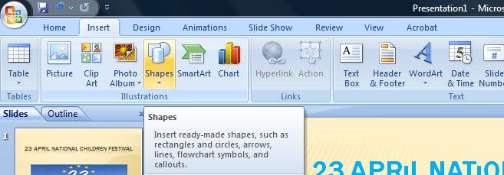

Firstly, you should click the Insert link. Then, you click the Shapes icon to add the automatic shape. There is small arrow to open the all shapes. Click the small arrow.

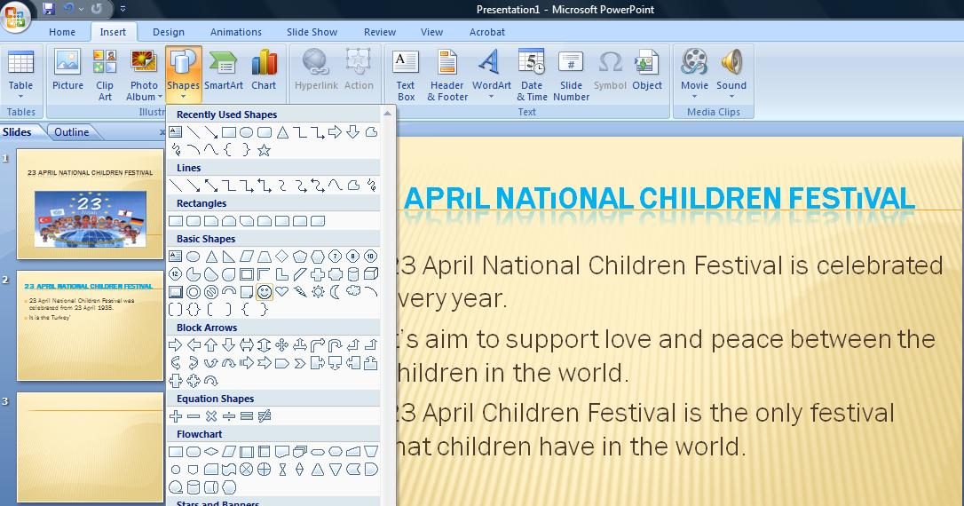

When you click the small arrow of shapes icon, all shapes open. Choose smile face to add.

Again, you can reasize of the autoshape.

☺ Congratulations! You just have created 3rd slide. ☺

10th Step: For the Last Slide
Now, you add the new slide from New Slide icon.

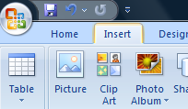
You should click the Insert link. Click the picture icon. From the file open dialog, you can choose picture to add. They are explained in the 4th step.

Congratulations! You created the presentation ☺
Final Step:
You did great job. However, you should start to slide show to view your presentation.
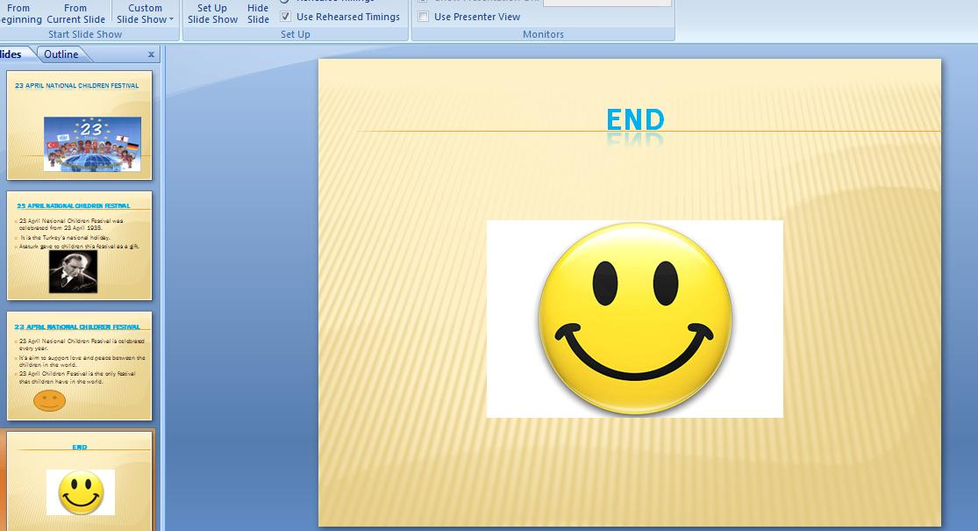
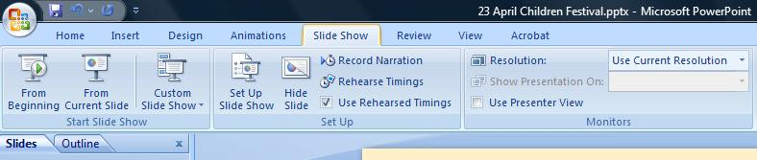
Firstly, click the Slide Show icon.
Click this icon to start the slide show from different page.
Click From Begining icon to start the slide show. It will start from first slide.

☺ Congratulations ☺
You have created the power point presentation

